Final for Math 361
Quantitative Methods for Fixed-Income Securities
May 24, 2005

Problems:
- Build a two-period (recombining) binomial tree for the normal model (Page 219, equation (11.1)) with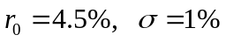, 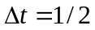 and 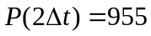.
  - Calculate the risk-neutral probabilities for branching out (in the first period).
  - Calculate a - maturity call option on 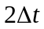-maturity zero-coupon bond with strike price $978.
  - Explain how to hedge the option.
- Build a 1-period interest-rate tree under the Salomon Brothers model (Page 251, equation (12.10)), with parameters 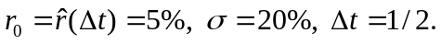 Determine the drift according to spot rate 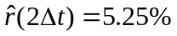.
- Let 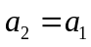 and extend the tree in Problem 2 to two periods. Then price an interest-rate floor with cash flows
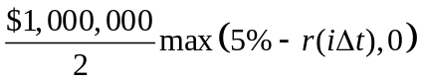, at 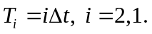
- Suppose that on May 20, 2005, a client of a trading desk wants to buy 6s of 8/15/2010 for $1m face value. The desk makes market with the following transactions:
    - On May 20, 2005, the desk sold to the client the bond of face value $1m at flat price 104-13 (for T+1 settlement).
  - On May 23, 2005, the desk lent out the payment to a third party who borrowed the money using the bond as a collateral, and the desk then delivered the bond to its client. The repo rate is 4.5%. On the same day, the desk buys the bond from open market at flat price 104-12 (again for T+1 settlement).
  - On May 24, 2005, the repo matures: third party returns the money with interest, and the desk returns the bond to the third party.
You are asked to
Calculate the P&L to the desk;
  - Calculate the cost of carry.
  - Find out the breakeven price.
========================== THE END ==========================

